Sears-Kay 100k and Bartlett Lake 200k Support Plan
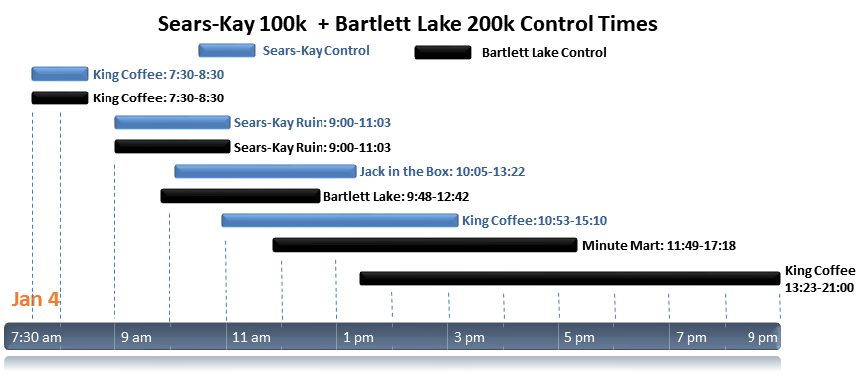
Start time: 7:30
Start Location: King Coffee Roastery https://goo.gl/maps/bxkVfiotVzJBUfTw6
- The coffee shop opens at 7:00
- START: King Coffee (100k, 200k): Breakfast snacks at start: Coffee, Danish, bananas, water
  - Mike
- CP 2: Sears-Kay Ruin (100k, 200k): 9:00-11:03. All climbing to that point. Expect 1st riders at 9:30 or so.
  - Mike – Breakfast: Water, coffee, Frappuccino, bananas, cookies, pastry, burritos?, hash browns?, trail mix
- CP 3:
  - Bartlett Lake (200k): Self supported
  - Jack in the Box, Carefree Hwy & 23rd Ave (100k): Jenn – Snacks: water, PB pretzel bites, cookies, bananas, M&Ms, Fig bars, trail mix
- CP 4:
  - Subway finish (100k): Mike – Lunch
  - Minute Mart, I-17 & New River Rd (200k): Jenn – Snacks: water, PB pretzel bites, cookies, bananas, M&Ms, Fig bars, trail mix
- CP 5:
  - Subway finish (200k): Mike – Lunch: Subway

