Hello Randos!
First, I’d like to welcome everyone to Colorado! I know that it doesn’t look like the Rockies are right out your door, but the number of Coloradans on the ride roster indicates that we must be in CO, so Welcome! I do promise that there will be no snow on the rides.

Here are some last minute notes about Saturday's rides. I know that there's a lot of stuff here, but please read through it so that you come prepared.
I plan to ride on Saturday, so Brian McGuire will be your Day of Ride Contact. He will be able to answer questions for you, but is not available for any SAG duties. His number is 602.410.8091. His number is on the Brevet card and the cue sheet.
- IF YOU DOWNLOADED THE CUE SHEET, RWGPS OR BREVET CARD BEFORE YOU RCVD THIS EMAIL, DOWNLOAD AGAIN – BOTH DISTANCES! I have updated the cue sheets and maps. You may need to refresh your browser to see the latest.
- The 300k/400k courses are starting concurrently. The 300k/400k routes are identical until mile 142.6, then they diverge. Make sure you're not blindly following the rider in front of you in case they're riding a different distance.
- Parking at the Start: THIS IS NEW! If you're driving to the start, please use the back of the parking lot at Denny’s (7400 W Chandler Blvd, Chandler, AZ 85226). Google map HERE. We have cleared this with Denny’s, so please park in the back and leave the closer spaces for the patrons. This will also be your finish control.
- Support on the rides: Brian will be supporting the ride. You can expect him to be in Buckeye (mile 59) with water & snacks. He will also be your lunch chef in Gila Bend (mile 100). After that, a lot will depend on the time-spread of riders and Brian’s stamina. So, you should assume that you will be self-supporting after Gila Bend.
  - Be aware that the stretch from Gila Bend to Maricopa (miles 100 -142) can be slow. Make sure you have enough water for that 42 miles.
- Construction: Unfortunately, we have some on the 300k route. The RWGPS has been modified to miss most of it. But, there is likely to be about ½ mile of unpleasantness. Here’s a photo of what it looks like. The traffic lane may be ridden, but traffic is likely to honk and do nasty driver stuff. Brian was able to ride the torn-up shoulder. Choose safety when you see it in person.
  - 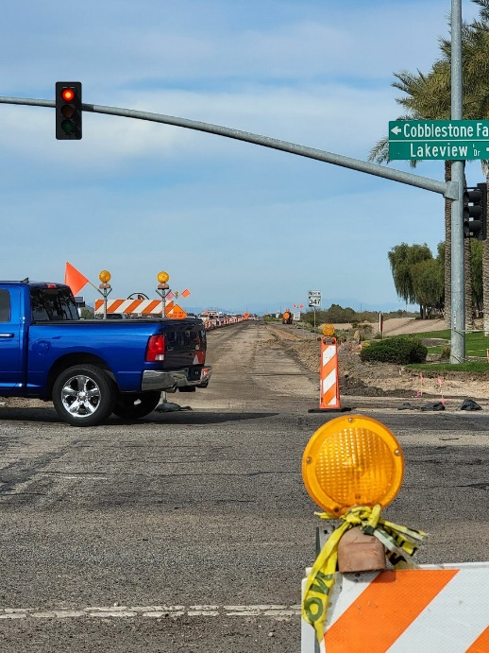
- Start Times: 06:00 for the 300k/400k. Please be there early enough to get your bike and yourself together so that everyone can start on time. I, or Brian, will give any last-minute instructions at about 05:55. Also, please check in with us so that we know who is out on the course.
- Lights & Reflective gear. All riders will be required to have headlights and taillights mounted to their bicycle and in use during all low-light situations. Helmet lamps are good as backups, but not allowed as your only light. Reflective vests and reflective ankle bands are also required and must be worn to start the events. Remember, be seen, be safe!
- You must bring your own documents. GPS files and cue sheets are linked at www.azbrevet.com, and the control cards are linked below.
- Every rider should be prepared to collect and submit proof of passage for this brevet. The current protocol is detailed here. www.azbrevet.com/EPP.html Please read and understand this info! If you have questions, ask BEFORE you start your ride.
- All Control information will be found on the Brevet cards. The cards can only be obtained by printing them in advance of the ride from these links. Note that a recent RUSA change now makes all Intermediate controls untimed. Yippee! I have left the reference closing times on the cards so that riders are able to gauge their progress against the Final control closing time, which is still required. Riders still need to execute the control instructions, but the timing is not important.
  - 300k: Brevet card HERE
  - 400k: Brevet card HERE
- Proof of passage must be submitted to the organizer @ mikesturgill@cox.net All proof of passage must be emailed within 48 hours of ride completion. The results for all riders will only be sent to RUSA after all results are received.
- If you are running late or can’t make it to the start, please text me (602.702.2132) so that I know whether you plan to ride or not.
- If you abandon the ride at any point, please text Brian (602.410.8091) to let him know.

Let me know if you have any questions.
-Mike

